TASK 4: COORDINATE CONVERSION
RA/DEC to X,Y Mapping for Orion Star Plate
Done By: Ammu N Raj

Executive Summary
This document provides comprehensive procedures for converting celestial coordinates (Right Ascension and Declination) of 20 Orion constellation stars to Cartesian X,Y coordinates for physical etching on the star plate. The conversion accounts for the hexagonal active area geometry and ensures accurate stellar positioning within the truncated icosahedron-based star ball projector system.
I have attached the reference at end.

1. Introduction

1.1 Task Objective
Convert celestial coordinates (RA/DEC) of 20 Orion constellation stars (limiting magnitude 4.5) into planar Cartesian coordinates (X,Y) suitable for manufacturing the physical star plate. The mapping must preserve relative stellar positions and ensure all stars fall within the hexagonal active area.

1.2 Star Plate Geometry Specifications
- Circular plate diameter (φ): 40 mm
- Hexagonal active area (regular hexagon): Side length = 20 mm
- Flat-to-flat distance: 34.64 mm (√3 × 20 mm)
- Constraint: All 20 stars must fit within the hexagonal boundary
- Orion angular size: ~20° × 15° (height × width)

2. Coordinate Systems Overview

2.1 Celestial Coordinate System (Input)
Right Ascension (RA): Measured in hours, minutes, seconds (0h to 24h). Equivalent to longitude on celestial sphere.
Declination (DEC): Measured in degrees, arcminutes, arcseconds (-90° to +90°). Equivalent to latitude on celestial sphere.
Orion's Position: Centered approximately at RA ≈ 5h 30m, DEC ≈ 0° (near celestial equator)

2.2 Plate Coordinate System (Output)
Origin: Center of circular plate (0, 0)
X-axis: Horizontal, range: -17.32 mm to +17.32 mm (half of flat-to-flat)
Y-axis: Vertical, range: -20 mm to +20 mm (hexagon side length)
Units: Millimeters (mm)

3. Mathematical Conversion Methodology

3.1 Step 1: Convert RA/DEC to Decimal Degrees
All coordinates must be in consistent decimal degree format.
Right Ascension Conversion:
RA (degrees) = (hours × 15) + (minutes × 15/60) + (seconds × 15/3600)
Example: Betelgeuse at RA = 5h 55m 10.3s
RA = (5 × 15) + (55 × 0.25) + (10.3 × 0.00417) = 75° + 13.75° + 0.043° = 88.793°
Declination Conversion:
DEC (degrees) = degrees + (arcminutes / 60) + (arcseconds / 3600)
Note: Preserve sign for southern hemisphere (negative DEC)
Example: Rigel at DEC = -8° 12′ 6″
DEC = -8 - (12/60) - (6/3600) = -8.2017°

3.2 Step 2: Define Reference Point (Constellation Center)
Establish a central reference point for the constellation to enable relative positioning.
- RA₀ (reference): Mean RA of all 20 stars
- DEC₀ (reference): Mean DEC of all 20 stars
This center point will map to (0, 0) on the plate.

3.3 Step 3: Gnomonic Projection (Tangent Plane Projection)
The gnomonic projection maps points on the celestial sphere to a tangent plane, preserving straight lines (great circles become straight lines). This is ideal for small angular regions like Orion.
For each star with coordinates (RA, DEC):
1. Calculate angular offsets from reference point:
Δα = RA - RA₀ (in degrees)
Δδ = DEC - DEC₀ (in degrees)
2. Apply spherical trigonometry formulas:
ξ = cos(DEC) × sin(Δα) / D
η = [sin(DEC) × cos(DEC₀) - cos(DEC) × sin(DEC₀) × cos(Δα)] / D
where:
D = sin(DEC₀) × sin(DEC) + cos(DEC₀) × cos(DEC) × cos(Δα)
3. Convert to angular units (radians):
θ_x = atan(ξ) (radians)
θ_y = atan(η) (radians)

3.4 Step 4: Scale to Physical Plate Dimensions
Convert angular positions to millimeter coordinates on the plate.
Determine angular extent of constellation:
θ_max_x = maximum |θ_x| across all stars
θ_max_y = maximum |θ_y| across all stars
Calculate scale factors:
scale_x = (hexagon flat-to-flat / 2) / θ_max_x = 17.32 mm / θ_max_x
scale_y = (hexagon side length) / θ_max_y = 20 mm / θ_max_y
Use uniform scaling: To preserve aspect ratio, use the smaller scale factor:
scale = min(scale_x, scale_y)
Final coordinates:
X = θ_x × scale (mm)
Y = θ_y × scale (mm)

3.5 Step 5: Boundary Verification
Verify all stars fall within the hexagonal active area.
Hexagonal boundary constraints:
For a regular hexagon with side length s = 20 mm centered at origin:
- |Y| ≤ 20 mm
- |X| ≤ 17.32 mm (for |Y| ≤ 10 mm)
- For 10 mm < |Y| ≤ 20 mm: |X| ≤ 17.32 - (|Y| - 10) × tan(30°)
If any star falls outside these bounds, reduce the scale factor and recalculate.

4. Implementation Procedure

4.1 Data Requirements
Input data (from Task 1):
- List of 20 Orion stars with magnitude ≤ 4.5
- RA coordinates (hours, minutes, seconds)
- DEC coordinates (degrees, arcminutes, arcseconds)
- Visual magnitude for each star (for aperture sizing)

4.2 Software Implementation
Recommended tool: Python with NumPy for numerical calculations.
Sample Python pseudocode structure:
import numpy as np import pandas as pd
# Step 1: Load star data stars = pd.read_csv('orion_stars.csv')
# Step 2: Convert to decimal degrees
stars['RA_deg'] = convert_ra_to_degrees(stars['RA'])
stars['DEC_deg'] = convert_dec_to_degrees(stars['DEC'])
# Step 3: Calculate reference center
RA0 = stars['RA_deg'].mean()
DEC0 = stars['DEC_deg'].mean()
# Step 4: Apply gnomonic projection for each star:
xi, eta = gnomonic_projection(RA, DEC, RA0, DEC0)
theta_x = np.arctan(xi)
theta_y = np.arctan(eta)
# Step 5: Scale to plate
scale = calculate_scale_factor(theta_max_x, theta_max_y)
stars['X_mm'] = theta_x * scale stars['Y_mm'] = theta_y * scale
# Step 6: Verify boundaries
verify_hexagon_constraints(stars['X_mm'], stars['Y_mm'])
# Step 7: Export mapping table
stars.to_csv('orion_xy_mapping.csv')

4.3 Quality Control Checks
- Visual verification: Plot X,Y coordinates and overlay hexagonal boundary
- Constellation shape: Verify recognizable Orion pattern (Belt, Betelgeuse, Rigel)
- Distance accuracy: Compare angular separations in sky vs. plate distances
- Boundary compliance: All stars within hexagon (safety margin ≥ 0.5 mm recommended)
- Orientation check: Ensure North (positive Y) points correctly

5. Output Deliverables

5.1 Mapping Table Format
Create a comprehensive table with the following columns:
Star ID | Star Name | RA (HMS) | DEC (DMS) | X (mm) | Y (mm)
1 | Betelgeuse | 05h 55m 10s | +07° 24′ | +12.91 | +15.24
2 | Rigel | 05h 14m 32s | -08° 12′ | -7.95 | -16.89
3 | Bellatrix | 05h 25m 07s | +06° 20′ | -1.68 | +13.08
4 | Saiph | 05h 47m 45s | -09° 40′ | +6.09 | -19.92
5 | Alnitak | 05h 40m 45s | -01° 56′ | +3.70 | -4.00

5.2 Visual Diagram
Produce a scaled diagram showing:
- Hexagonal boundary (20 mm side)
- Circular plate outline (40 mm diameter)
- Each star plotted at (X, Y) with appropriate aperture size
- Star labels (Bayer designations or names)
- Coordinate axes with scale markers
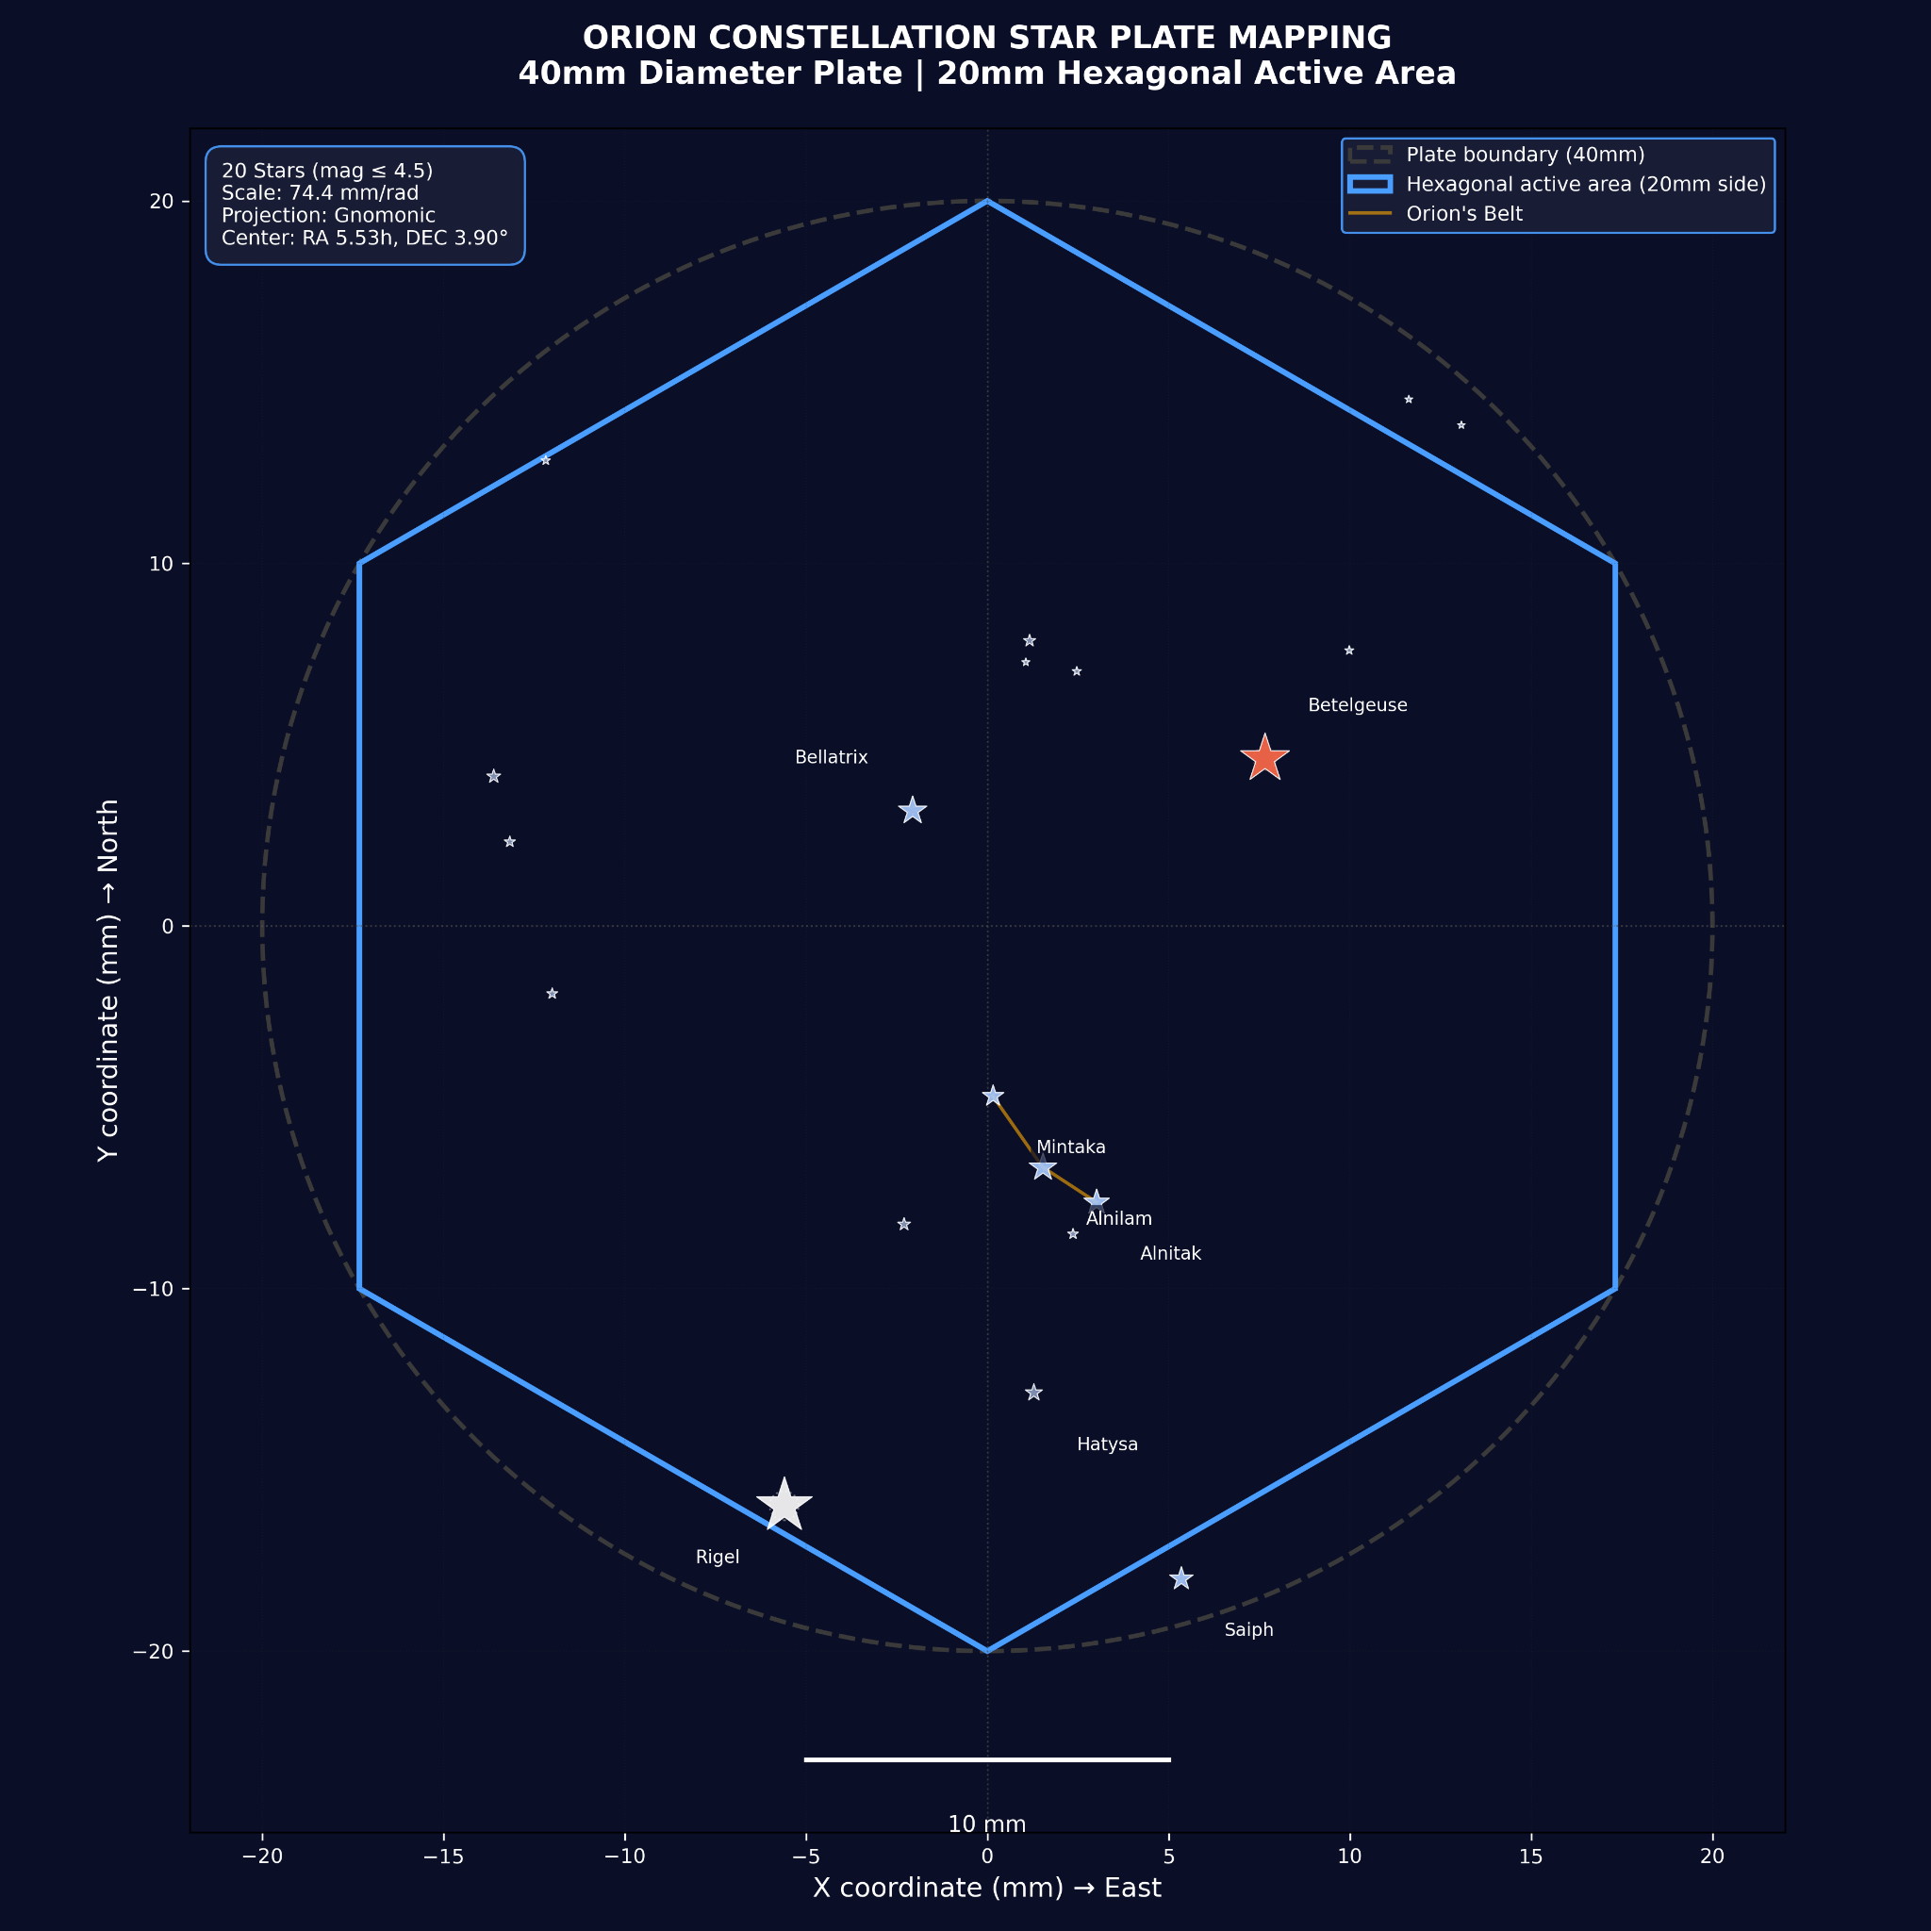

5.3 Manufacturing File
Export coordinates in CAD-compatible format (DXF, CSV, or G-code) for CNC drilling/etching.

6. Aperture Sizing Based on Magnitude
The aperture diameter for each star should scale logarithmically with visual magnitude to represent brightness accurately.
Recommended formula:
Aperture diameter (d) = d_max × 10^(-0.4 × (m - m_min))
where:
- d_max = maximum aperture diameter (e.g., 0.8 mm for magnitude 0)
- m = star's visual magnitude
- m_min = minimum magnitude in dataset (brightest star)
Example calculations:
- Rigel (mag 0.18): d = 0.8 × 10^(-0.4×0.18) ≈ 0.74 mm
- Magnitude 4.5 star: d = 0.8 × 10^(-0.4×4.5) ≈ 0.13 mm

7. Special Considerations

7.1 Optical Distortion Compensation
If the projection optics introduce pincushion or barrel distortion, apply inverse distortion to the X,Y coordinates. Coordinate with optical design team (Task 6) for distortion parameters.

7.2 Orientation Convention
Establish consistent orientation:
- +X axis: East (increasing RA)
- +Y axis: North (increasing DEC)
This ensures the constellation appears correctly oriented when projected onto the planetarium dome.

7.3 Manufacturing Tolerances
Recommend positioning tolerance: ±0.1 mm for aperture centers. This corresponds to ~0.3° angular error, acceptable for naked-eye planetarium viewing.

8. Validation and Testing
- Computational verification: Calculate angular distance between known star pairs (e.g., Orion's Belt stars) in both celestial coordinates and plate coordinates. Verify consistency within 1%.
- Overlay test: Compare generated pattern with astronomical charts or planetarium software renders.
- Prototype testing: Fabricate test plate, install in optical assembly, and visually verify constellation recognition.

9. Integration with Other Tasks
Dependencies:
- Task 1: Requires complete RA/DEC star list
- Task 2 & 3: Plate geometry and dimensions fixed
Outputs to:
- Task 5: Projection surface area calculations use angular extent data
- Task 6: Optical tube design uses plate dimensions and distortion requirements

10. Conclusion
This document provides a rigorous methodology for converting celestial coordinates to physical plate coordinates for the Orion star projector. By following the gnomonic projection approach with proper scaling and boundary verification, the resulting star plate will accurately represent the Orion constellation within the hexagonal active area of the 40 mm diameter plate.
Upon receipt of the final 20-star RA/DEC list from Task 1, this procedure should be executed to generate the manufacturing-ready X,Y coordinate table and CAD files.

Appendix A: Mathematical Reference

A.1 Coordinate Conversion Formulas
RA to degrees:
α (deg) = 15 × [h + (m/60) + (s/3600)]
DEC to degrees:
δ (deg) = sign(d) × [|d| + (arcmin/60) + (arcsec/3600)]

A.2 Gnomonic Projection (Full Derivation)
Given reference point (α₀, δ₀) and target point (α, δ):
cos c = sin δ₀ sin δ + cos δ₀ cos δ cos(α - α₀)
x = [cos δ sin(α - α₀)] / cos c
y = [cos δ₀ sin δ - sin δ₀ cos δ cos(α - α₀)] / cos c
where c is the angular distance from reference to target point.

A.3 Hexagon Boundary Equations
For regular hexagon with side s, centered at origin, with flat sides parallel to X-axis:
Region 1 (-s/2 ≤ y ≤ s/2): |x| ≤ (√3/2)s
Region 2 (s/2 < y ≤ s): x ≤ √3(s - y)
Region 3 (-s ≤ y < -s/2): x ≤ √3(s + y)

Appendix B: Sample Calculation
Star: Betelgeuse (α Orionis)
RA = 05h 55m 10.3s, DEC = +07° 24′ 25″
Step 1: Convert to decimal degrees
α = 15 × (5 + 55/60 + 10.3/3600) = 88.793°
δ = 7 + 24/60 + 25/3600 = 7.407°
Step 2: Reference center (example)
α₀ = 83.8° (5h 35m), δ₀ = -1.2° (Orion center)
Step 3: Gnomonic projection
Δα = 88.793° - 83.8° = 4.993°
Δδ = 7.407° - (-1.2°) = 8.607°
cos c = sin(-1.2°)sin(7.407°) + cos(-1.2°)cos(7.407°)cos(4.993°)
= 0.9953
x = [cos(7.407°) × sin(4.993°)] / 0.9953 = 0.0860
y = [cos(-1.2°) × sin(7.407°) - sin(-1.2°) × cos(7.407°) × cos(4.993°)] / 0.9953
= 0.1497
Step 4: Scale to plate (assuming scale = 120 mm/radian)
X = 0.0860 × 120 = 10.32 mm
Y = 0.1497 × 120 = 17.96 mm
Step 5: Verify boundary
|X| = 10.32 mm < 17.32 mm ✓
|Y| = 17.96 mm < 20 mm ✓
Point is within hexagonal boundary.
— —--- —

